**VIRTUAL MEMORY OPERATING SYSTEM**

**EXERSIZE SOLUTION 9TH EDITIONTH**

**MADE BY : ASHISH SHAH MCA STUDENT NITW**

**Q. Under what circumstances do page faults occur? Describe the actions**

**taken by the operating system when a page fault occurs**

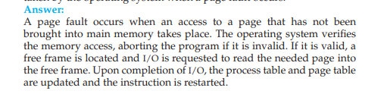

**Q2**

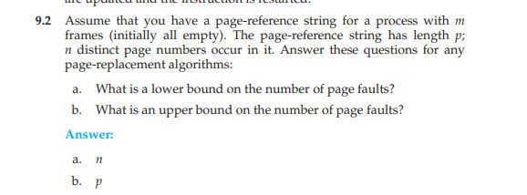

**Q3**

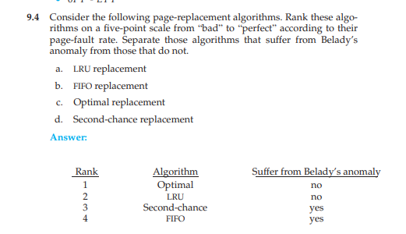

**QDiscuss the hardware support required to support demand paging.**

**ANS :** 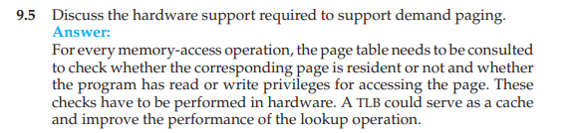

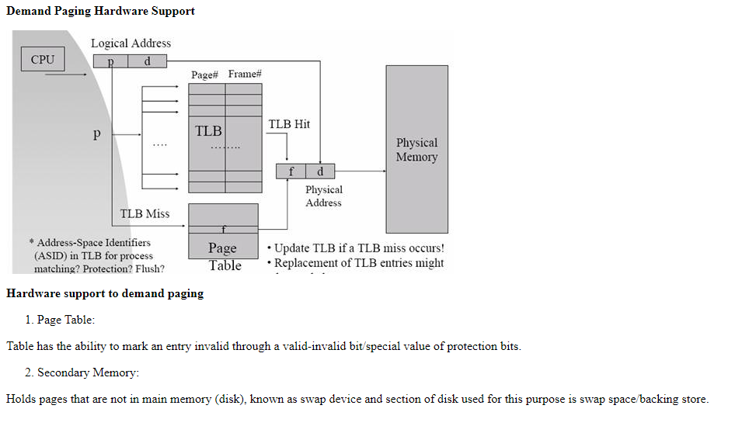

**Q. An operating system supports a paged virtual memory. The central**

**processor has a cycle time of 1 microsecond. It costs an additional 1**

**microsecond to access a page other than the current one. Pages have 1,000**

**words, and the paging device is a drum that rotates at 3,000 revolutions**

**per minute and transfers 1 million words per second. The following**

**statistical measurements were obtained from the system:**

**• One percent of all instructions executed accessed a page other than**

**the current page.**

**• Of the instructions that accessed another page, 80 percent accessed**

**a page already in memory.**

**• When a new page was required, the replaced page was modified 50**

**percent of the time.**

**Calculate the effective instruction time on this system, assuming that the**

**system is running one process only and that the processor is idle during**

**drum transfers.**

ANS :-